## Supplementary material

### Trinity Bay seasonal inshore acoustic surveys (2003-2005)

Inshore seasonal acoustic surveys (January, June, September 2003-05) in Trinity Bay, Canada were conducted from a 23 m inshore research vessel (CCGS Shamook) using a calibrated EK500 echo-sounder with a towed 38 kHz transducer. Surveys followed a fixed transect design and covered both the main portion of Trinity Bay as well as the four arms (Suppl. Fig 1). When acoustic targets were encountered, sampling was conducted using bottom and midwater trawls to target the portion of the water column where the acoustic signal occurred. Samples were obtained from most aggregations. Length, sex and maturity stage were recorded for all fish sampled and ages determined for two fish per sex per 0.5 cm interval.

Spatial patterns in age composition were similar to those patterns reported by Winters (1970) with older, larger capelin overwintering in the main portion of the bay while juvenile capelin were more prevalent in the inner arms. In all months except June, capelin were aggregated along the sides of the trench around 200 m depth, whereas in June capelin were present in the arms and in shallower water closer to shore at the bottom of the bay.

**References**

Winters GH (1970) Biological changes in coastal capelin from the over-wintering to the spawning condition. Journal of the Fisheries Research Board of Canada 27:2215-2224

**Supplementary Figures**

Fig. S1 Inshore seasonal survey in Trinity Bay, Newfoundland, Canada (2003-2005) of acoustic transects (solid lines) and 100, 200 and 500 depth contours (dashed lines).

Fig. S2 Acoustic survey transects (solid lines) for the annual Div. 3L spring acoustic survey including the inshore survey of Trinity Bay, Newfoundland.

Fig. S1

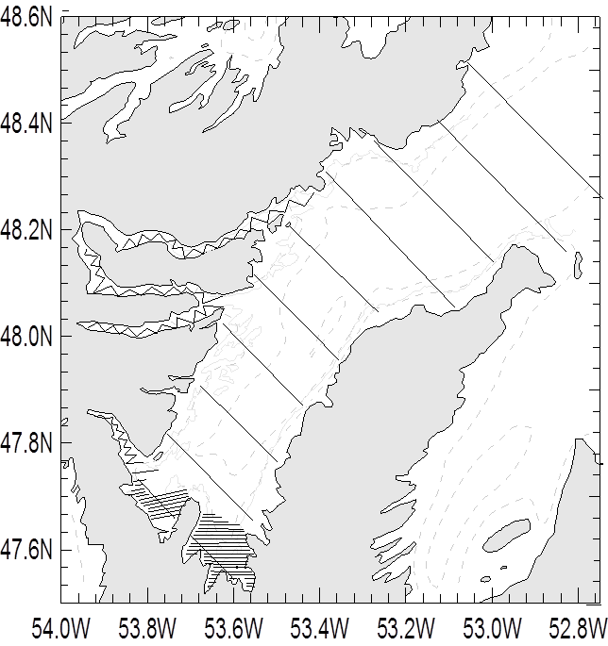

**Fig. S2**

